**RK3568:** Help to develop cloud office / cloud education industry

The RK3568 CPU is a quad-core A55 with a main frequency of up to 2GHz. Integrated G52 GPU. Built-in independent NPU, the computing power is 0.8Tops, which can meet the multi-functional requirements of cloud office and cloud education market.

* 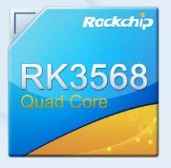Quad core 64-bit cortex - A55
* Arm G52 2EE
* LPDDR4/ LPDDR4X/ DDR4/ DDR3/ DDR3L/ LPDDR3, ECC
* Built in NPU, providing 0.8t computing power
* Support 4K 60fps H.265 / H.264/ VP9 video decoding
* Support 1080p 60fps H.265 / H.264 Video Editing
* Support 8M ISP and HDR
* Support HDMI / eDP / LVDS / MIPI / RGB / T-CON interface
* Support USB2.0/U SB3. 0/PCIE3. 0/PCIE2.1/SATA3. 0/QSGMII

**01. Efficient video and picture encoding and decoding, smooth operation of office online class**

Compared with the current cloud terminal product solutions on the market, the general decoding capacity is 1080p 60 frames, and RK3568 supports 4K 60 frame video decoding, which can decode multiple video sources at the same time, and the decoding efficiency is significantly improved. It can automatically adjust the video quality and network resolution according to the situation. At the same time, it cannot be automatically adjusted according to the network.

In addition, RK3568 has a dedicated hardware JPEG decoding processor, 240m pixels processing capacity per second, and supports concurrent processing of multiple small images to meet the refresh of various local areas of the terminal picture. Compared with most similar products using software decoding, RK3568 is more efficient.

**02. It is equipped with dual Gigabit Ethernet ports, with faster network speed**

Rk3568 supports two Gigabit Ethernet ports, which is convenient for multi computer networking and can meet the needs of multi person classes and conferences for high-speed networks. Most similar products usually only support a single 100m bandwidth network port, which has great scene limitations. Two Gigabit Ethernet ports are supported to facilitate multi computer networking and faster network speed.

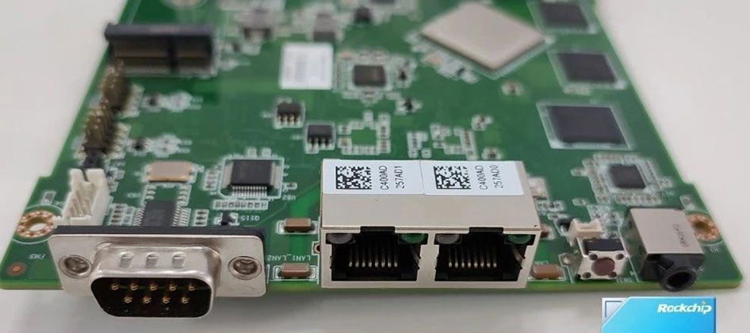

**03. Low power consumption, more power saving and less heating**

Rk3568 adopts dynamic frequency and voltage regulation technology to effectively reduce power consumption, longer endurance and work more efficiently. At the same time, the product has less heating and high safety.

**04. It has rich integration interfaces and strong scene expansibility**

Rk3568 has rich display and peripheral interfaces, supports multi-screen abnormal display, and office split screen is more efficient; Support 2.5k screen and integrate eDP / MIPI / LVDS / HDMI and other screen interfaces; Support USB 3.0, can support up to 4 USB interfaces; It supports PCIe 3.0 and can expand Wi-Fi 6, 5G and other modules.

**05. Adapt to mainstream domestic operating system**

In addition to supporting Android and Linux systems, RK3568 can also adapt to multiple mainstream domestic OS, which is suitable for richer software ecology.

Ruixin micro's new cloud terminal solution rk3568, with five technical advantages, will open up new imagination and market space for multi scenario cloud terminal hardware upgrading and ecological innovation in the 5g era, and bring users a more efficient and stable cloud terminal experience.

* Support 2.5K screen
* Integrated eDP / MIPI / LVDS /HDM equal screen interface
* Support USB 3.0
* Support up to 4 USB interfaces
* Support PCIe 3.0
* Expandable wifi6, 5g and other modules

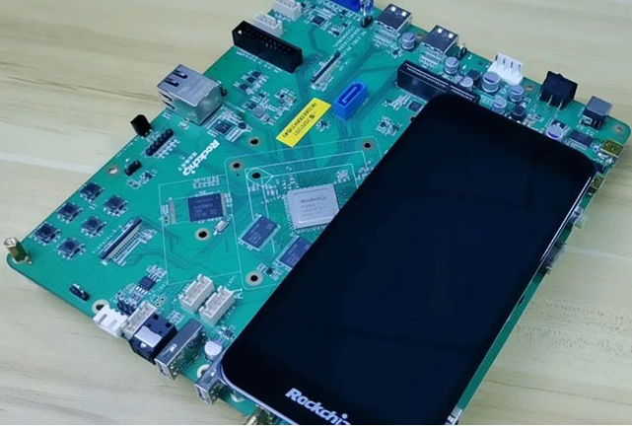

**Introduction to the advantages of Rk3568 cloud office / cloud education product scheme**

- New generation mainstream AIoT platform chip

**Rk3568 cloud office / cloud education product solution advantages video web page pictures are smoother, office is not stuck**

* Powerful processor performance
* Have 4K@60 Frame video playback capability
* CPU, A55, 2 GHz
* Dedicated hardware JPEG decoding processor
* Support dynamic rate switching
* Network speed 100MB / s, definition 1080p
* Network speed 250kb / s, definition 720P

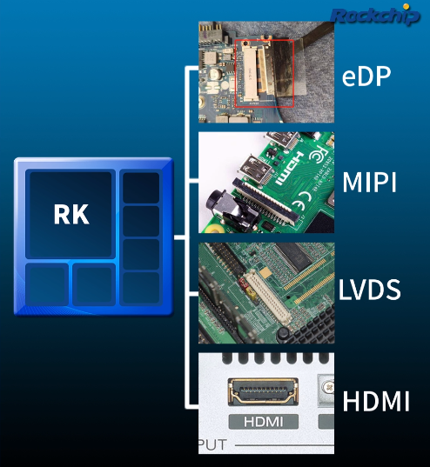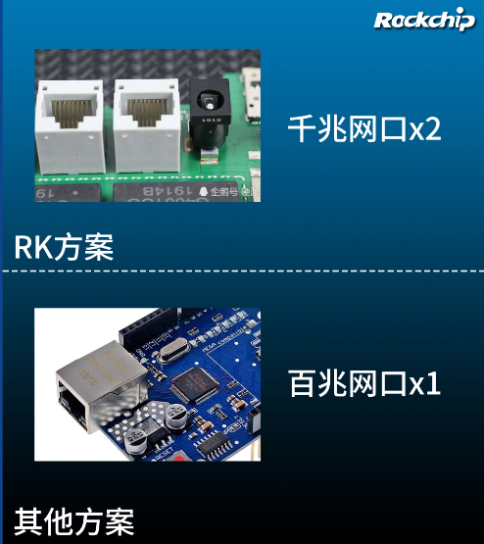

**Rk3568 cloud office / cloud education product solution advantages Gigabit Ethernet port faster network speed**

* Dual Gigabit Ethernet port
* Convenient multi device series / Networking

**R3568 advantages of cloud based office technology support**

Support dynamic frequency modulation and voltage regulation technology

Greatly reduce power consumption / heating

**Rk3568 cloud office / cloud education product scheme has the advantages of rich display and peripheral interfaces**

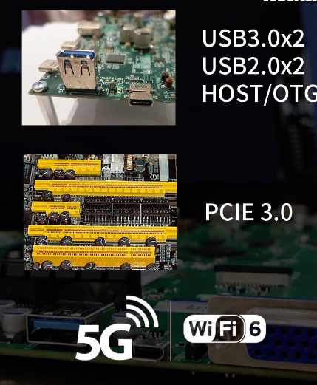

* Support three screen display
* More efficient office / Teaching
* Support multiple display interfaces
* Support 2.5k high score screen
* Complete peripheral interfaces
* Supports up to 4-way usb3 0 interface
* Support wi-fi6 / 5G

**Rk3568 cloud office / cloud education product solution advantages**

* The supply of domestic chips is stable and reliable
* Support mainstream operating systems
* Support Android Linux domestic operating system

**Conclusion:**

* Videos / Web pages / pictures are smoother, and the office is not stuck
* Speed
* Gigabit Ethernet port, faster network speed
* Support power-saving technology, work stably and do not burn
* It has rich display and peripheral interfaces
* The supply of domestic chips is stable and reliable

**RK3399:**

The RK3399 is the highest performance chip in Rockchip's product line, featuring high performance and scalability in applications. The hardware specifications of the chips are industry-leading. The **GPU** of RK3399 adopts the new generation high-end graphics processor Mali-T860 of quad-core ARM, integrates more bandwidth compression technologies (such as smart overlay, ASTC and local pixel storage), and supports more graphics and computing interfaces. The processor **Mali-T860** integrates more bandwidth compression technologies and has excellent overall performance. Overall performance has improved by 45% over the previous generation. The **CPU** of RK3399 adopts **big.LITTLE** large and small core architecture, dual-core Cortex-A72+quad-core Cortex-A53, which is technologically leading in terms of overall performance and power consumption, and

**The following shows the seven performance advantages of the RK3399:**

* Integrated USB3.0 Type-C dual port, and supports audio and video output of Type-C display port.
* Dual ISP with 800MPix/s pixel processing capability supports simultaneous data input and advanced processing (such as 3D and depth information extraction) for dual cameras.
* MIPI/eDP interface supports 2560×1600 screen and dual-screen display.
* HDMI2.0 interface and H.265/H.264/VP9 4K@60fps support decoding and displaying HD video.
* The PCI-e built-in interface supports PCI-e-based high-speed Wi-Fi and storage expansion.
* Supports 8-channel digital microphone array input.
* Full support for systems compatible with Android, Linux and other operating systems.
* It has strong compatibility and expansion capabilities, and can be applied to VR, game consoles, tablet computers and other multi-function terminals.

**1.** For smart devices such as VR, RK3399 has advantages in hardware, including screen with 20ms delay, 90Hz refresh rate, 4K UHD decoding and 2K low persistence, high-precision positioning and tracking system, excellent HDR camera shooting technology, excellent 3D Processing power and HD H.265/H.264 video parsing capability.

**2.** For tablet PCs, game boxes and other products, RK3399 is based on powerful CPU, higher interface standard, faster transmission speed, supports H.265/VP9 4K@60fps10bit video playback and output capability, provides the terminal with faster Computing speed and better visuals. encoding, better picture decoding, game engine and 3D image processing capabilities.

**3.** In addition to tablet PC, VR, TV-BOX, notebook PC, automotive and communication fields, RK3399 is based on sufficient scalability and can be applied to various terminals in industrial and consumer fields, including smart home appliances, advertising players/multi-functions PC, financial POS machine, in-vehicle control terminal, thin client, VOIP video conference, security/surveillance/police affairs and IoT fields.

**4.** RK3399 will be suitable for electronic whiteboards, electronic school bags, face recognition equipment, drones, robots, game terminals, game peripherals, mobile game on-hook servers, home appliances, advertising machines/all-in-one machines , financial POS, vehicle control industry, thin client (cloud service), VOIP video conference system, education tablet, karaoke entertainment, medical, security/monitoring/police, industrial control, IoT field, VR Nearly 100 industry application products such as video and VR.

**5.** The use of RK3399 The platform's home entertainment host terminal products have technological leadership in multiple display interfaces, GPU, audio and video decoding, interconnection with multiple terminals, and human-computer interaction.

**2.** The VR head display device using the RK3399 platform can achieve a delay of less than 20ms under the optimized algorithm, and at the same time, it can achieve a 90Hz refresh rate, 4K UHD decoding and ultra-high-definition H.265/H.264 video resolution capabilities. Through the Type-C or HDMI+USB interface, an external VR headset can bring an immersive virtual reality experience to the product.

**Rockchip RK3399's** open interface and open source system not only help terminal equipment manufacturers use one chip for global product line layout, but also realize rapid product mass production, cost control, and technology application. Its open source system can also meet the demands of terminal manufacturers for product personalization and differentiation, truly solve the pain points of the industry chain, and will be of great value to the development of global intelligent hardware.

**RK3399 & RK3568 Comparison**

The processor Rockchip RK3399 has more cores, the maximum frequency of Rockchip RK3399 is greater, that the thermal dissipation power of Rockchip RK3568 is less. The Rockchip RK3568 was started more recently.

|  |  |  |  |  |  |  |  |  |
| --- | --- | --- | --- | --- | --- | --- | --- | --- |
| **Processor** |  | **Rockchip RK3399** |  |  |  | **Rockchip RK3568** |  |  |
| Market (main) |  | **Single-board computer** |  |  |  | **Single-board computer** |  |  |
| ISA |  | **ARMv8-A (64-bit)** |  |  |  | **ARMv8.2-A (64-bit)** |  |  |
| Microarchitecture |  | **Cortex-A72, Cortex-A53** |  |  |  | **Cortex-A55** |  |  |
| Family |  | **RK3300** |  |  |  | **RK3500** |  |  |
| Part number(s), S-Spec |  | **RK3399(K), RK3399 K** |  |  |  | **RK3568** |  |  |
| Release date |  | **2016 Q1** |  |  |  | **2020 Q2** |  |  |
| Lithography |  | **28 nm HKMG** |  |  |  | **22 nm** |  |  |
| Cores |  | **6** |  |  |  | **4** |  |  |
| Threads |  | **6** |  |  |  | **4** |  |  |
| Base frequency |  | **1,5 GHz** |  |  |  | **1,8 GHz** |  |  |
| Turbo frequency |  | **2,0 GHz** |  |  |  | **-** |  |  |
| Energy cores |  | **4x ARM Cortex-A53 @ 1,5 GHz** |  |  |  | **-** |  |  |
| High performance cores |  | **2x ARM Cortex-A72 @ 2,0 GHz** |  |  |  | **4x ARM Cortex-A55 @ 1,8 GHz** |  |  |
| Cache memory |  | **1,512 MB** |  |  |  | **256 KB** |  |  |
| Max memory capacity |  | **4 GB** |  |  |  | **4 GB** |  |  |
| Memory types |  | **LPDDR3-1866, LPDDR4 SDRAM** |  |  |  | **DDR3, DDR3L, LPDDR3, DDR4 ECC** |  |  |
| Max PCIe lanes |  | **4** |  |  |  | **1** |  |  |
| TDP |  | **7 W** |  |  |  | **5 W** |  |  |
| GPU integrated graphics |  | **ARM Mali-T860** |  |  |  | **ARM Mali-G52** |  |  |
| GPU execution units |  | **4** |  |  |  | **2** |  |  |
| GPU shading units |  | **64** |  |  |  | **32** |  |  |
| GPU base clock |  | **600 MHz** |  |  |  | **850 MHz** |  |  |
| GPU boost clock |  | **600 MHz** |  |  |  | **950 MHz** |  |  |
| GPU FP32 floating point |  | **81,6 GFLOPS** |  |  |  | **54,4 GFLOPS** |  |  |
| Socket |  | **SoC** |  |  |  | **SoC** |  |  |
| Drystone MIPS |  | **32 600 DMIPS** |  |  |  | **-** |  |  |
| Crypto engine |  | **AES 128/192/256, DES/3DES, SHA1/SHA256/MD5, PRNG, TRNG** |  |  |  | **-** |  |  |
| Security |  | **Trustzone** |  |  |  | **-** |  |  |
| Max display resolution |  | **4K@60fps** |  |  |  | **-** |  |  |
| Video decoding |  | **H.265/H.264 4K@60fps** |  |  |  | **-** |  |  |
| Video encoding |  | **H.264 1080p@30fps** |  |  |  | **-** |  |  |
| Modem |  | **10/100/1000M Ethernet** |  |  |  | **-** |  |  |
| Connectivity |  | **HDMI 2.0, USB 2.0, USB 3.0** |  |  |  | **-** |  |  |
| Audio |  | **I2S, PCM, SPDIF** |  |  |  | **-** |  |  |
| (Android 64-bit) Geekbench 4 single core |  | **1 144** |  |  |  | **711** |  |  |
| (Android 64-bit) Geekbench 4 multi-core |  | **2 776** |  |  |  | **1 921** |  |  |
| (SGEMM) GFLOPS performance |  | **23,9 GFLOPS** |  |  |  | **16,8 GFLOPS** |  |  |
| (Multi-core / watt performance) Performance / watt ratio |  | **397 pts / W** |  |  |  | **384 pts / W** |  |  |

**Performances:**

Performance comparison between the two processors, results are generated on benchmark software such as Geekbench 4. Geekbench 4 is a complete benchmark platform with several types of tests, including data compression, images, AES encryption, SQL encoding, HTML, PDF file rendering, matrix computation, Fast Fourier Transform, 3D object simulation, photo editing, memory testing. This allows us to better visualize the respective power of these devices. For each result, we took an average of 250 values on the famous benchmark software.

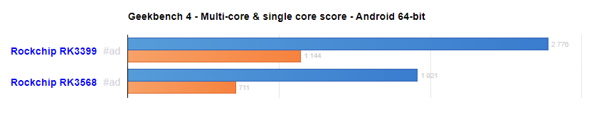

In single core, the difference is 61%. In multi-core, the differential gap is 45% onAndroid 64-bit.